Report on a visit to University College Dublin to explore ultrasound in the pregnant mouse using the ultrasound biomicroscope.

Anna David

Clinical Lecturer in Obstetrics & Gynaecology
Maternal and Fetal Medicine Fellow
Institute for Women’s Health
University College London

The aim of my visit to Professor Fionnuala McAuliffe’s unit at University College Dublin (UCD) was to find out more about the new VisualSonics Vevo ultrasound biomicroscope that had been recently installed at the Conway Institute. This is specifically designed for use in small animals such as rodents and I was interested to find out how it could be used to measure uterine artery and umbilical artery volume flow in the pregnant mouse and to visualise the mouse fetus in vivo.
My interest in the machine has developed from my research into uteroplacental blood flow and fetal growth restriction. Fetal growth restriction (FGR) affects up to 8% of all pregnancies and is severe in 1:500 fetuses. Affected fetuses are at increased risk for fetal and neonatal death, birth asphyxia and major long term morbidity. There is no current treatment. Attempts to treat it using for example aspirin, oxygen or sildenafil have been unsuccessful. Impaired materno-placental perfusion is believed to be the cause of FGR in humans. Reducing uterine blood flow (UBF) in sheep leads to FGR; what is not known is whether increasing UBF increases fetal size. Using an adenovirus vector containing the VEGF gene, my research has demonstrated a significant and long-term increase in UBF after local expression of VEGF in the uterine artery of pregnant sheep.
The next step is to investigate whether increasing UBF in a normal small animal such as a rat or mouse will increase fetal size and whether this will rescue growth-restricted fetuses in small animal models of FGR. There are many FGR mouse models (eg maternal adenovirus sFlt1 administration resulting in a pre-eclampsia like phenotype, and Insulin-like Growth Factor knockouts), reproducing the different aetiologies of FGR we see in clinical practice. I wanted to explore further how uteroplacental blood flow could be measured in the pregnant mouse and whether it would be possible to measure fetal growth longitudinally in small animals such as the mouse. Quantification of uterine artery blood flow has recently been described by Professor Lee Adamson and her group in Toronto, Canada (Mu et al, 2006) using the Vevo ultrasound biomicroscope that Professor Adamson has developed with Visualsonics. The ultrasound biomicroscope operates at a range of frequencies between 19 and 55 MHz which provides excellent views at low depth of penetration making it ideal for imaging adult and fetal mice. For example the fetal heart can be studied by echocardiography (Stypmann, 2007), an area in which Professor McAuliffe has a particular interest.
I spent 6 days in February 2008 in Dublin at the National Maternity Hospital in Holles Street and the Conway Institute, University College Dublin. On my first day I met Professor McAuliffe and spent the morning in the Fetal Medicine Unit where she does scan lists. It was interesting to compare and contrast the counselling that is given to couples in a country in which termination of pregnancy is not frequently performed or even offered. However it was also reassuring to find that much of the practise was the same as in my unit at UCL, even down to the same machine, types of needles and technique for amniocentesis.
In the afternoon we went to the Conway Institute at UCD where I met Niamh Corrigan, Professor McAuliffe’s PhD student who was setting up the machine. My visit coincided with a 3 day training session on the machine by one of the Visualsonic experts. I had the opportunity to see the animal set up whereby mice are anaesthetised (“knocked down”) in a chamber and then placed onto a movable platform where anaesthesia is maintained via a nasal cone. The table has integral monitors to which the four limbs are held outstretched so that ECG, respiration rate and temperature can be measured allowing the sonographic view of the cardiac cycle to be synchronized.
We first studied a non-pregnant adult animal to perform echocardiography. The abdomen was cleared of hair using Nair hair removal lotion (!) and then a 2cm layer of warmed ultrasound gel was put onto the abdomen. The 30MHz probe was held still while the movable table on which the mouse was anaesthetised was moved up until the probe was within the gel but not touching the abdomen. The view of the adult heart was superb, and it allowed complete views of the 4 chambers, outflow and inflow tracts to be done with Doppler assessment of blood flow. We then moved down the animal to view the uterine arteries in this non-pregnant mouse. The vessels were seen tracking along the lateral border of each uterine horn and the flow could be sampled to produce a waveform although colour flow is not yet possible in the ultrasound biomicroscope. The vessel needs to be as parallel as possible to the ultrasound beam to ensure an accurate assessment of blood flow and by manipulating the movable platform and the probe it was possible to achieve this. The vessel diameter measured 0.19mm and the velocity of blood flow was 30mm/second. The whole examination took approximately 20 minutes and within a few minutes of turning off the anaesthetic gas the mouse was back in its cage licking its fur.
We next examined a pregnant mouse that was 12 days postconception. The uterine horns were enlarged but there were no obvious embryos with only small amounts of what appeared to be blood clot within them. We concluded that this pregnancy had failed, although in the mouse there is no outward appearance of miscarriage in the form of vaginal bleeding.
I spent the next day seeing more of the Vevo ultrasound biomicroscope in action. We studied a pregnant mouse at 11.5 and one at 14 days post conception that had approximately 5 fetuses. We measured uterine artery blood flow which was higher than in the non-pregnant animal (44mm/second, Figure 1a). The umbilical artery Doppler waveforms were also obtained (Figure 1b).

Figure 1 a 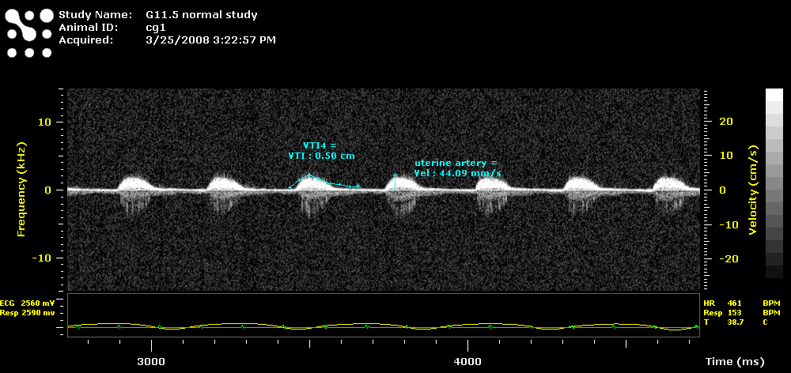

Figure 1 b 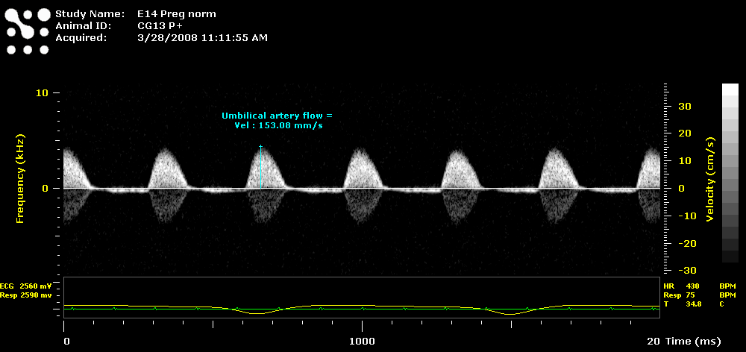

The fetal hearts could be easily examined and the traditional views obtained such as the 4 chamber view, outflow tracts etc. and fetal cardiac function could also be assessed. We saw the brain, face, lens, and typical views for fetal biometry such as the BPD, OFD and AC, and also the fetal kidney, liver and bladder.
The following day I spent at the National Maternity Hospital in Holles Street in the Fetal Medicine clinics where I saw a variety of very interesting cases. On the last day of my visit I attended the annual Fetal Medicine conference organised by National Maternity Hospital. There were a variety of presentations. It was particularly interesting to hear about management of pregnancies complicated by fetal abnormalities such as severe hydrocephalus and how the problems associated with their delivery are overcome. Many of these pregnancies are terminated early in gestation in London and so we never need to develop ways to manage them. There was discussion about how to best achieve a vaginal delivery where the fetus has a structural abnormality such as severe hydrocephalus that may interfere with vaginal birth but from which it is likely to die after birth.
During my stay I had the opportunity to present my research at the Holles Street weekly grand round which generated much discussion on the ethical issues on prenatal gene therapy and whether such therapy might work. I also did some sightseeing around Dublin including a trip to the Guinness factory and to see the Book of Kells in Trinity College. I had some great evenings out for dinner with Professor McAuliffe and her family, with the FMU department and with the Visualsonics representatives. The weather held while I was there and we had some beautiful sunny days.
I am currently exploring the feasibility of purchasing an ultrasound biomicroscope machine for use in mice with other research groups at UCL and I hope to submit an application for funding in the next few months. The visit to Dublin allowed me to get some pilot data that will be useful in this application and for a project exploring fetal growth restriction in mouse models. I would like to thank the BMFMS for funding my trip which was extremely useful and a real success.

