BMFMS/LSTM
GLOBAL HEALTH FELLOWSHIP APPLICATION FORM
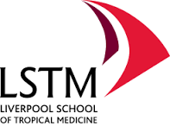 | 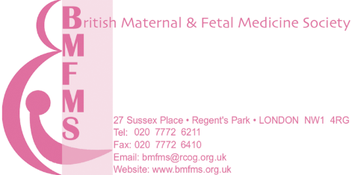  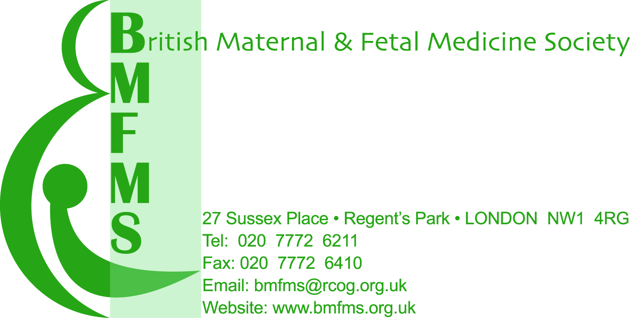

Please note the opening date for applications is 1st July 2017 and the closing date is 31st October 2017. Interviews will be held on Friday 26th January 2018.
Please send completed applications to srafferty@rcog.org.uk and copy to emma.coyle@lstmed.ac.uk. If you have not received email confirmation within 5 working days then please resend.

Please type or write in black ink and block capitals.

Full Name:
Organisation:
Position:
Correspondence Address:
Telephone Number (incl. country code):
Email Address:

Employment History
(Include any previous experience in a low or middle income country):

Previous research or audit conducted:

Please complete the following statement (500 words max)
I am attracted to a fellowship in Global Health because:

Proposed research project (1,000 words max)
Background and relevance to global health
Proposed research question(s)
Proposed approached to address the research question(s)

UK trainees must have written evidence of support for Out of Programme Experience from their TPD or Head of School for their application to be considered. I confirm that if necessary I will seek approval for Out of Programme Experience and present written evidence of confirmation by the interview date of Friday 26th January 2018.

Signed

I certify that I am a fully paid up member of BMFMS at the time of submission.  Signed  Please note: an electronic/typed signature is acceptable if the form is received from the NHS or academic email account of the applicant. | Date:

OFFICE USE ONLY
Date application received |  | Membership Number
Emailed receipt to applicant |  | Membership date

