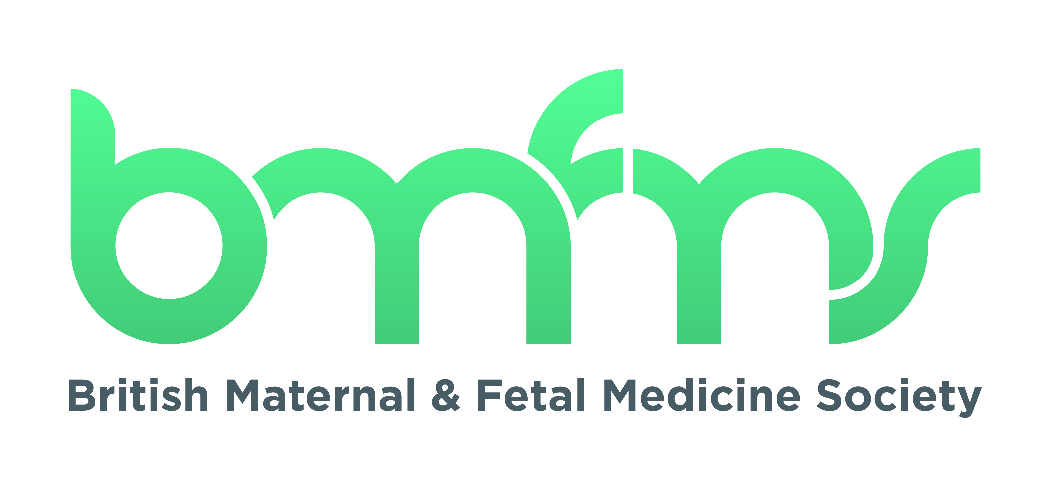

BMFMS Annual General Meeting
Monday 4th October 2021 at 17:00
Virtual via Zoom

- Welcome
The Honorary Secretary, Emma Ferriman (EF), welcomed everyone to the meeting.

- Minutes of last meeting
The minutes were circulated to members. No comments were received. The minutes were agreed.

- Presidential update
BMFMS President Myles Taylor (MT) noted how radically things had changed in his presidency: he had recently visited the new RCOG building and was impressed by how forward thinking it was with its digital theatre and area to make podcasts reaching out to millions of people; MT had also visited his old university and noted that the Churchill hospital which used to be a series of Nissen huts when he was at Oxford has been rebuilt and has immense research facilities. Queen Charlotte’s hospital where he worked 20 years ago now has focussed ultrasound on twin –twin.
MT noted Covid has thrust all types of things on us such online clinical meetings and MDT, telemedicine scans, networks all facilitated by Teams and Zoom which have changed the way we work. The BMFMS have changed in its core areas, eg online conference, and in the ways we have influenced opinions and education. MT said our values are the same, some things never change, we need to hold on to the good and embrace anything that would improve pregnancy care.
BMFMS submitted evidence to the Health & Social Care Committee on Safety of maternity service in England, chaired by Jeremy Hunt MP in October 2020. The report was published by the parliamentary committee in June 2021. The Government's response was published in September 2021. These documents are now on the BMFMS website.
MT said BMFMS have held monothematic conferences eg on Fetal genomics with the Fetal Genomics Group and also partnered with BAPM on the 2021 conference on inequalities. MT said he felt the future of conferences is to combine face to face and online ie hybrid. MT said BMFMS value working with others and would like to thank BAPM, not only for the inequality meeting, but also for the Pre-term labour conference in 2020. MT said BMFMS has also reached out to MOMs and renewed our commitment to working with them and perhaps BICS and the Obstetric Anaesthetic Association.

MT said the courses we have run have been extremely well received. MT said he was concerned a little about education being purely online because this will become wearying and we need to support the next generation.

MT said he was confident BMFMS has survived the Covid pandemic and was financially viable and in a good position to face the future.

MT said it gave him great pleasure to welcome the first female president, Katie Morris (KM) and is sure she will do a fantastic job and wished her the very best of luck. MT thanked the committee especially the Treasurer, Tracey Johnston and Hon Secretary, EF and KM in her role as the Abstract Coordinator. He also thanked Stella Rafferty (SR). MT wished the new committee the best of luck.

EF said the committee and members of BMFMS would like to thank MT for the amazing job he has done and are particularly grateful for him for extending his term through the difficult time of the pandemic. EF also thanked David James, who was part of the first organising BMFMS committee for all the work he has done for the society.

- Results of election for President
EF welcomed:
  - Prof Katie Morris

- Election results (since December 2020)
EF welcomed:

- Maternal medicine rep Dr Aarthi Rachel Mohan
- Education and Training rep Dr Marie O'Sullivan
- Trainee rep Dr Adalina Sacco
- Abstract Co-ordinator Dr Fionnuala Mone to replace Prof Katie Morris
EF gave special thanks to Marie O’Sullivan and Adalina Sacco for helping out at the RCOG Career fair.

- Finance update
TJ said this time last year the Society was concerned about financial uncertainties as a result of the pandemic and this is why the bursaries were suspended.

TJ reported the BMFMS account have been signed off and we have opened a further bank account to protect the Society’s funds. At moment BMFMS is in a healthy position, BMFMS holds funds of currently £186.5K in the bank.

Expected income this financial year is expected to include:
- Membership fees: £26K
- BMFMS/RCOG courses approx. £93K virtual courses have resulted in more attendees from UK and around the world
- BMFMS Prenatal Genomics Virtual Study Day, in collaboration with the FGG – this course didn’t make a profit as a result of not attracting sponsorship as companies seem to prefer face to face meetings. TJ thanked CFS, the conference organisers for absorbing the loss from their management fee.

Expected expenditure this financial year is expected to include:
- Outstanding for bursaries: £40K (the period to claim bursaries has been extended so these outgoings may be over a 18 month period, this is because much of the research was suspended due to the pandemic)
- Staff and desk costs: £23K
- Professional fees: £2.5k – this covers the accountants but this is figure may increase as BMFMS may pay for legal advice on governance to ensure the society is being run as it should be.
TJ said that we feel that we should have a proper face to face BMFMS conference next year but we have to be wary of booking a big venue and facing a significant loss.
TJ said she feels uncomfortable that we have £186K in bank and not allocating bursaries, keeping in mind we need to ensure we are financially secure.
EF thanked TJ for doing a great job.

- Bursaries
Mina Savvidou (MS), BMFMS Prize Coordinator, said bursaries were suspended during the past year owing to the pandemic. BMFMS are now looking at a joint bursary with WoW and possibly with the Twins Trust. MS asked for opinions.

TJ said because a lot of research is suspended we need to decide at December committee meeting what we should do with the bursaries.

Fionnuala Mone (FMo) said we could do a joint bid with Illumina for a genomics bursary. KM said we need to consider our remit as a charity and need to get value for money. KM said being able to support people starting in research is an important thing we do as a society.

- Incoming President
KM thanked MT, who stayed on for extra time to support the Society through very difficult times and the committee really appreciated his leadership and the stability that provided.

KM said she liked to communicate via Twitter and gave out her twitter feed details @kt2morris for anyone who wanted to follow her.

KM introduced herself briefly, she said she was a consultant in obstetric and fetal medicine at Birmingham’s Women’s Hospital where she also did her training. KT said she is also a professor of Obstetrics and Maternal & Fetal medicine and more recently has become the Director of the Birmingham Clinical Trials Unit delivering a portfolio of 56 randomised control trials. KM said she will draw on those skills she has gained through these roles for her role as President.

KM said that her goals would be, those of the Society ie:
- Disseminating knowledge
- Facilitating research
- Facilitating education
- Development and Implementation of high quality evidence based care
- Providing a forum- KM said this has been difficult during the pandemic and that she recalls how much she had enjoyed meeting people at the first BMFMS conference she attended and being part of a society; she missed this, and the ability to provide mentorship and opportunities for trainees
KM said that we need to think about where we fit within the funding model for research and what we can do to address the problems of doing research during the Covid pandemic and where we should focus our efforts.
KM said regarding education, providing courses during the pandemic has shown how BMFMS might provide education in addition, and separate to our joint courses with RCOG.
KM said our study days have been very successful and strengthened our relationship with other societies. KM said we are considering having a hybrid conference at end of next year. This was to ensure we have time to get high quality speakers. We are also looking at having a smaller venue to reduce the financial risk and to go places we haven’t gone before. A hybrid meeting also allows attendance for people who can’t get study leave and for those overseas. We are also planning on having further monothematic days and a celebratory 25th year event.
KM said being the first female president raises the question of how we make sure the committee, and working groups that give feedback on guidelines and policy consultations, are representative of the women we represent. We also need to think about how we improve pregnant people’s involvement.
KM said we are struggling to reach our wider membership at the moment and would like those present at the AGM to encourage friends/colleagues to join the society and become involved in its work. KM said we going to run a membership survey to try to find out why the Society doesn’t get the level of interaction we would like with members.
EF said we look forward to working with KM.

- AOB
David James said he would like to put on record that he and Martin Whittle met last week and were reflecting on the start of the society 25 years ago. DJ said the vision then was to draw people together of like minds and clearly there was an enthusiasm for it. DJ said the amount of progress the Society has made is immense. DJ gave his congratulations to those who took the baton on for doing so well and say good luck for the future.

EF said hopefully we will see each other in person at next year’s conference and AGM and thanked everyone for attending.

